- Pre-requisites and Installations
The document is walkthrough guide for installation steps and steps to run script.

- Tools :
  - Anaconda Jupyter Notebook

- Modules used and installation:
  - - Requests
  - - csv
  - - xml.etree.ElementTree
If any of the module gives the error “No Module found error: $module name “after importing “import $module name”, please install on windows:
  - Py -m pip install $module name
- Alternate:
If you are using Anaconda Jupyter Notebook, follow below steps:
  - Steps 1: Download Anaconda individual addition


  - Step 2: Go to Environments
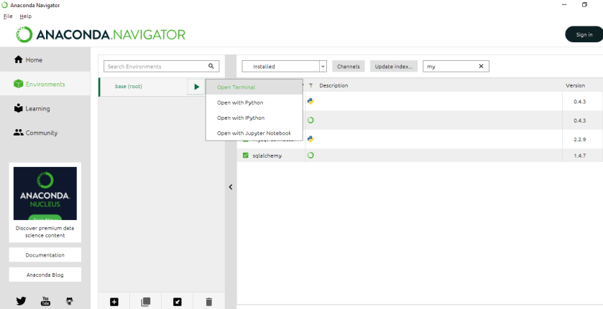

  - Step 3: Install the modules as in screenshot
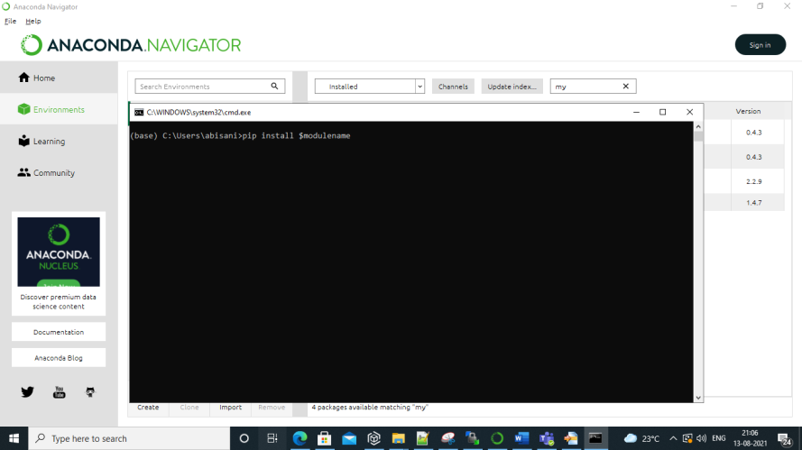

- Use Case:
  - Retrieves "Top Stories" from this parliament data RSS feed endpoint: https://www.europarl.europa.eu/rss/doc/top-stories/en.xml

- Solutions:
  - Step 1: Launch Jupyter Notebook
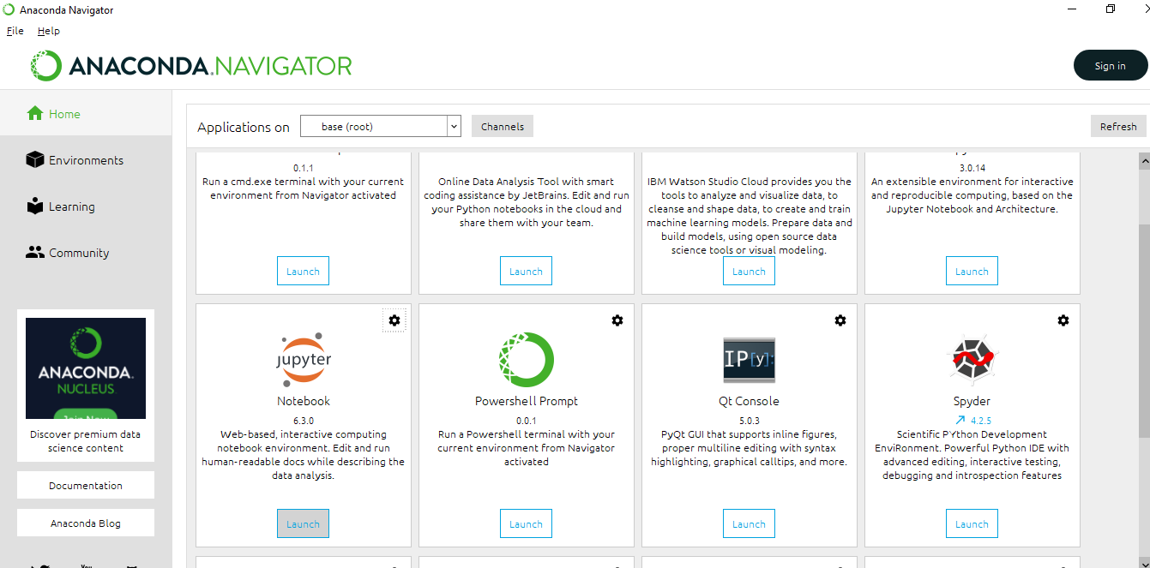

  - Step 2 : Upload the downloaded file :
top_stories.ipynb from the Git link mentioned in the mail .
  - Step 3: Open the file: top_stories.ipynb .
  - Step 4: Run the File: top_stories.ipynb and check for the root folder for the export_top_stories_csv file :

